1. Find all the information about each products

db.products.find().pretty();

1. Find the product price which are between 400 to 800

db.products.find({product_price: { $gt: 400, $lt: 800 }});

1. Find the product price which are not between 400 to 600

db.products.find({product_price: { $not: { $gt: 400, $lt: 600 } }});

1. List the four product which are greater than 500 in price

db.products.find({product_price: { $gt: 500 }}).limit(4);

1. Find the product name and product material of each products

db.products.find({}, {product_name: 1, product_material: 1});

1. Find the product name and product material of each products

db.products.find({"id": "10"});

1. Find the product name and product material of each products

db.products.find({}, {_id: 0, product_name: 1, product_material: 1});

1. Find all products which contain the value of soft in product material

db.products.find({ product_material: "Soft" });

1. Find all products which contain the value of soft in product material

db.products.find({ $or: [{ product_price: 492.00 },{ product_color: "indigo" }]});

1. Delete the products which product price value are same

db.products.aggregate([

{ $group: { _id: "$product_price", count: { $count: {} } } },

{ $match: { _id: { $ne: null }, count: { $gt: 1 } } }

]);

db.products.deleteMany({ product_price: { $in: [36, 47] } });

Screenshots:

**1. Find all the information about each products**

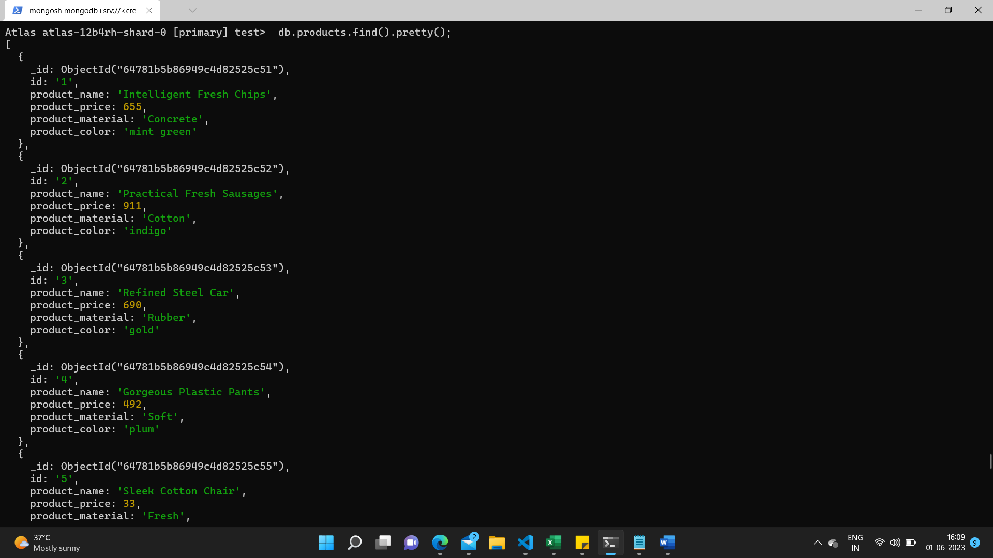









**2. Find the product price which are between 400 to 800**



**3. Find the product price which are not between 400 to 600**

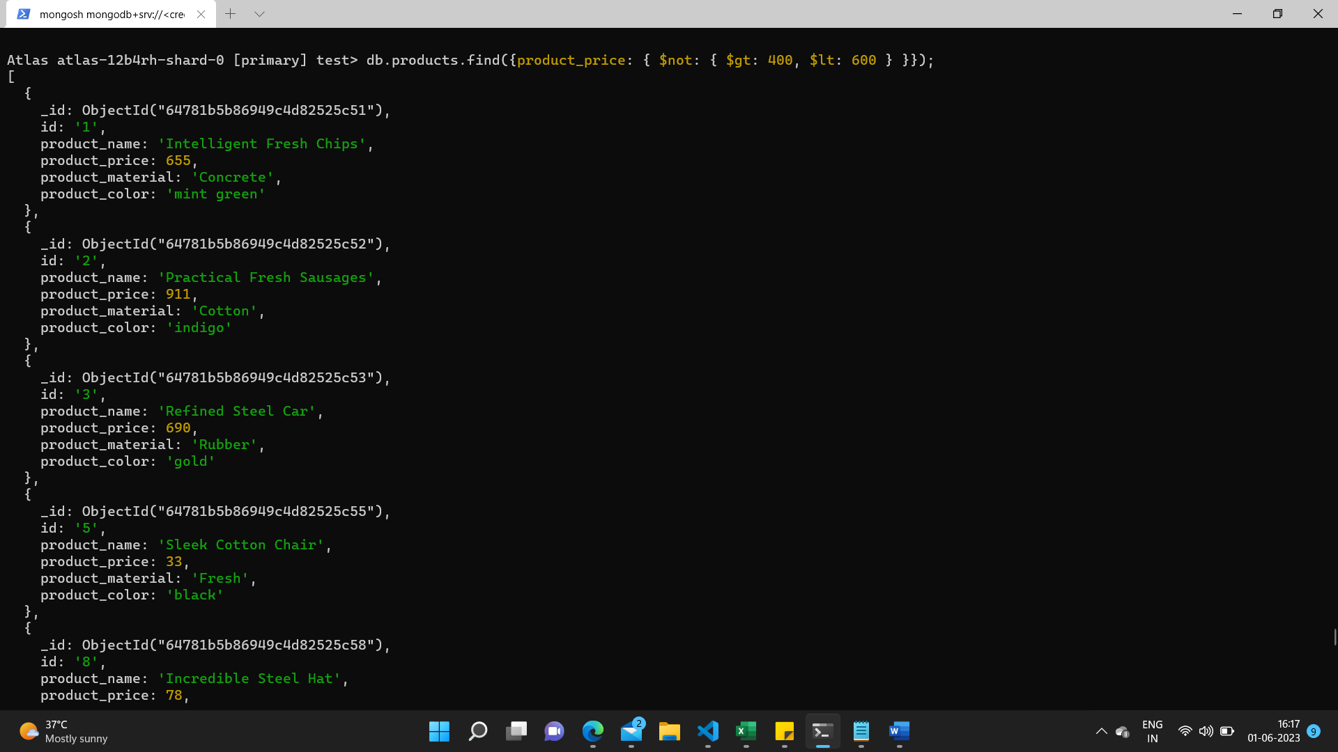









**4. List the four product which are greater than 500 in price**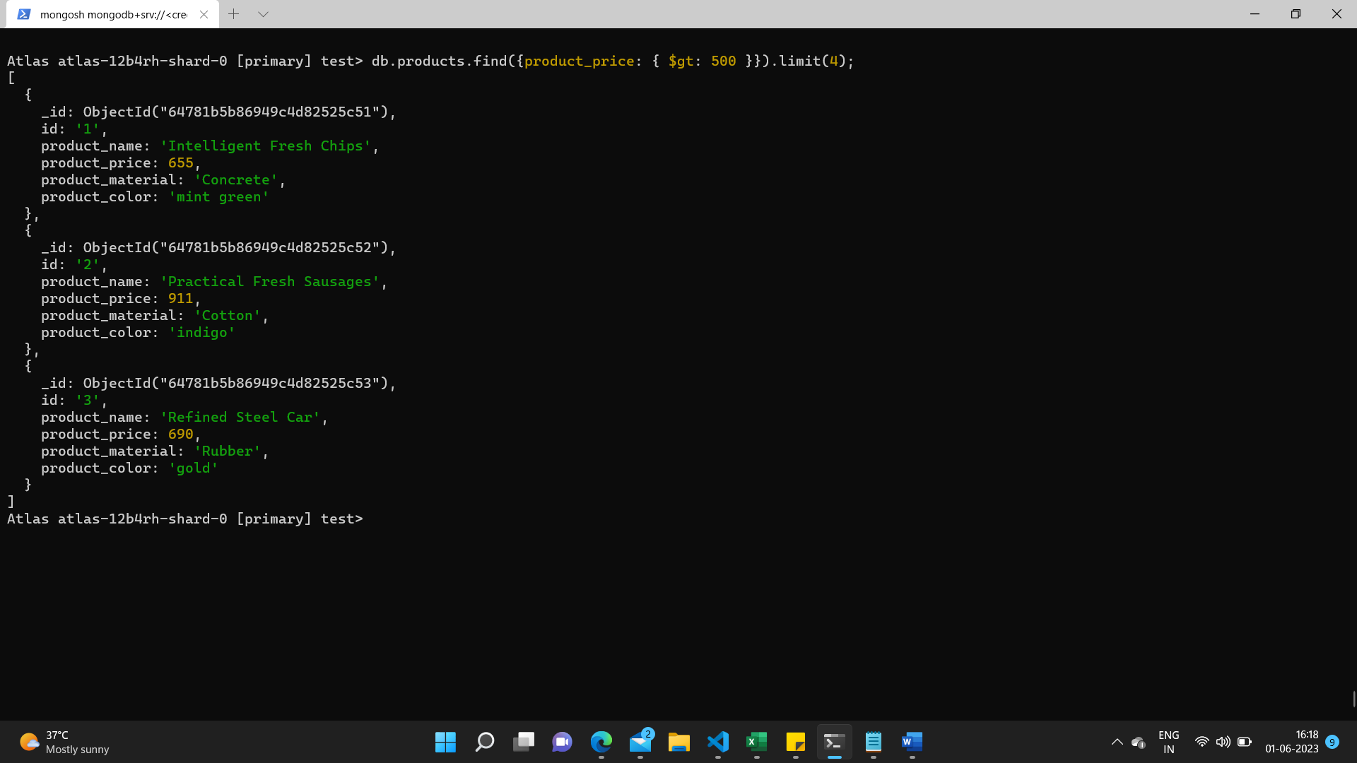

**5. Find the product name and product material of each products**

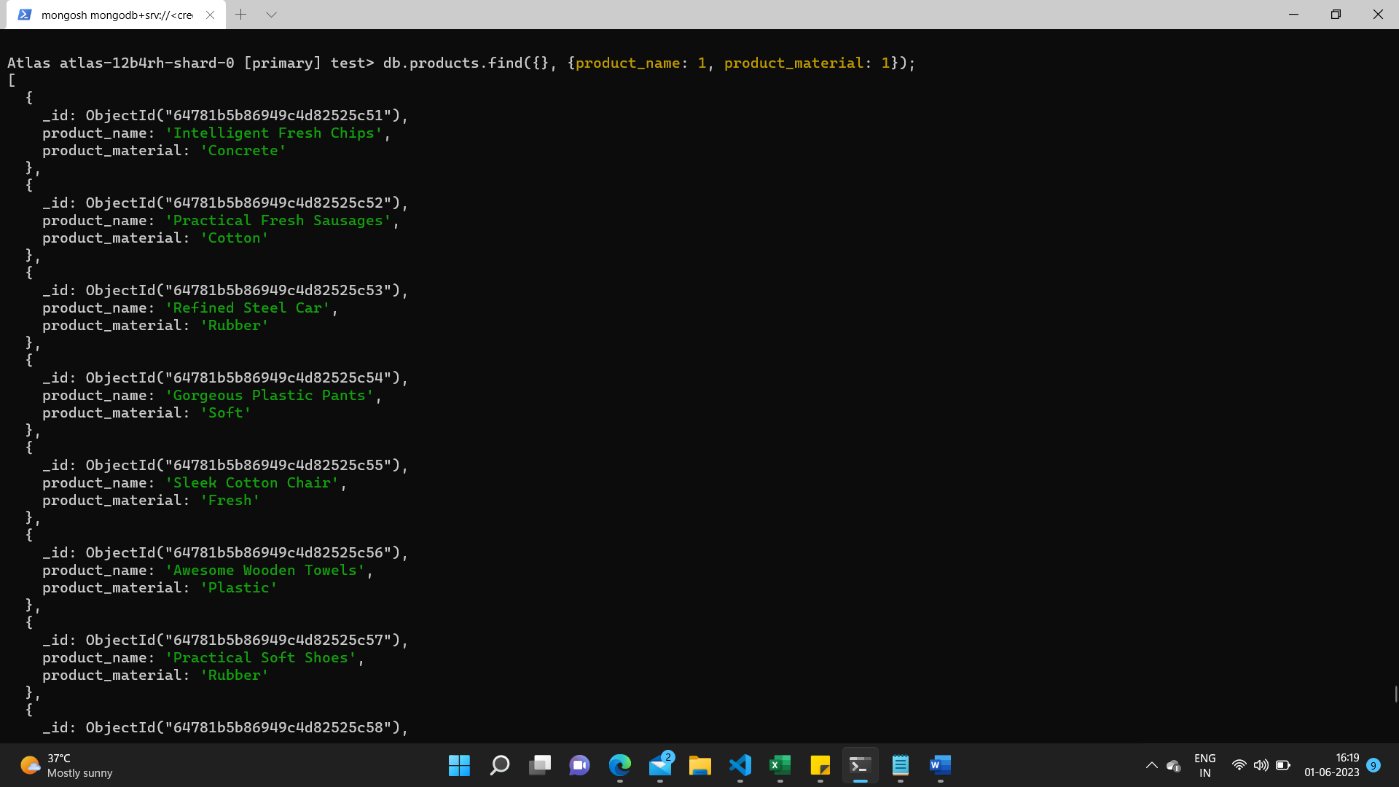







**6. Find the product with a row id of 10**

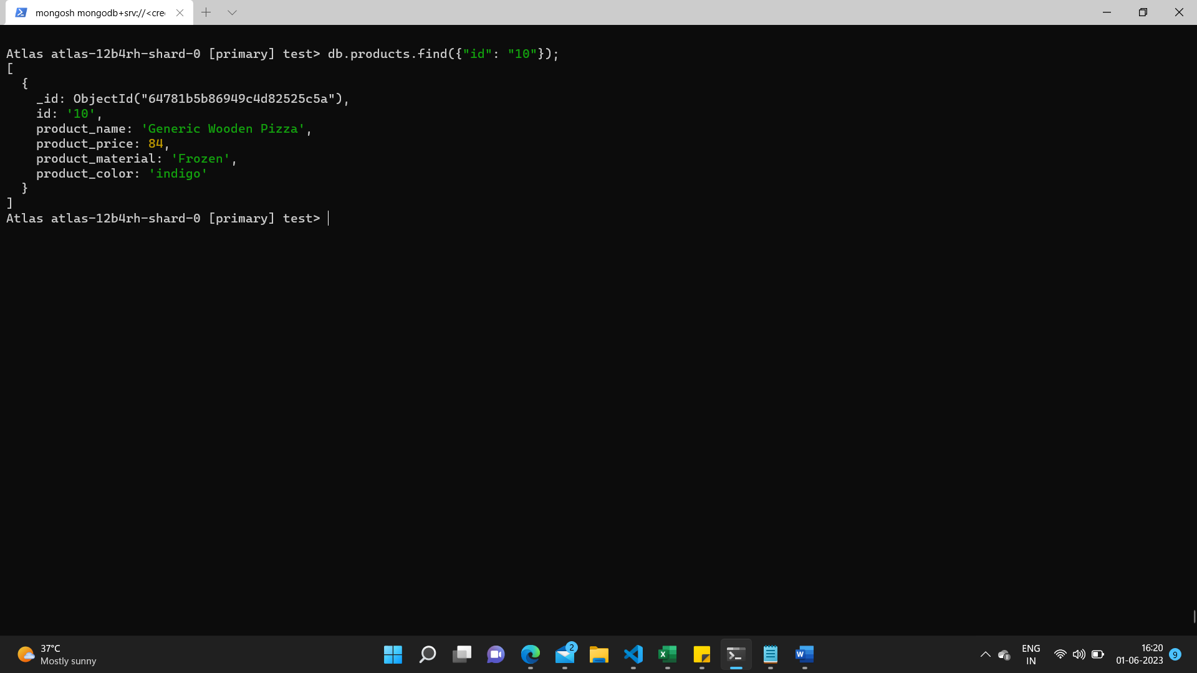

**7. Find only the product name and product material**

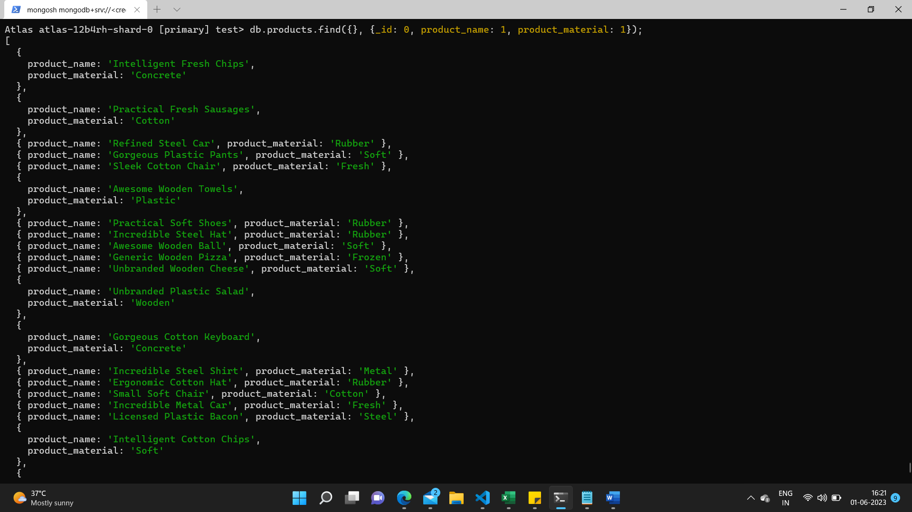

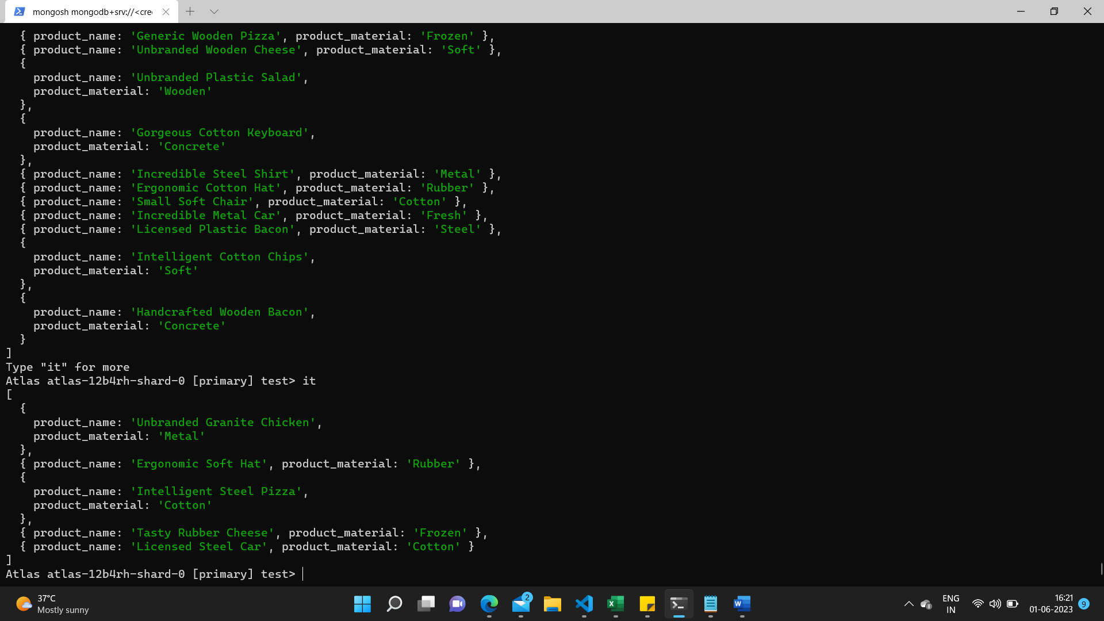

**8. Find all products which contain the value of soft in product material**

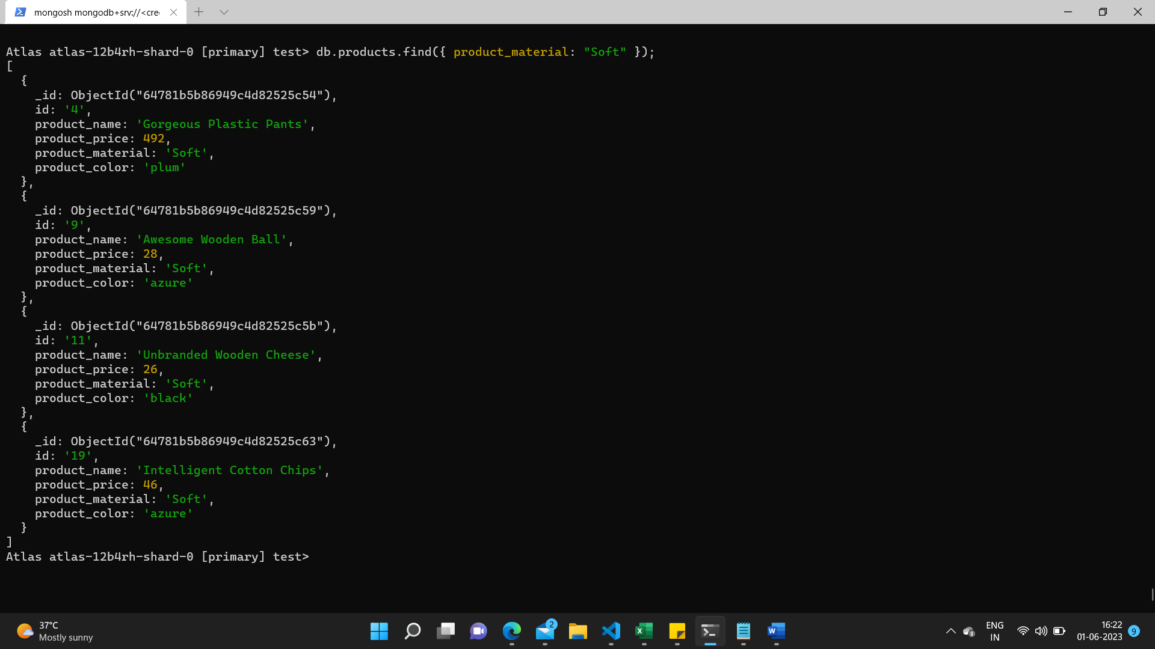

**9. Find products which contain product color indigo and product price 492.00**

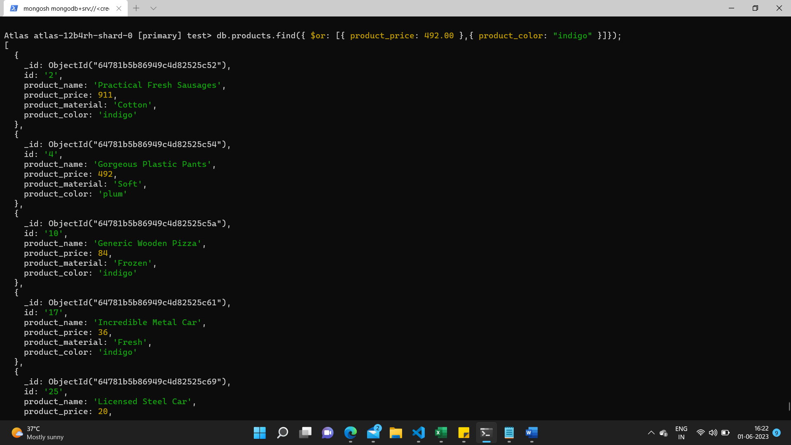

**10. Find products which contain product color indigo and product price 492.00**

